Problem statement
- Create 2 pages and submit the zipped folder of assignment which should have the following files (along with other supportive files and folders):
  - Home.html
  - Register.html
  - Main.js
  - Main.css
Note: Use the exact name for the solution to be evaluated
- UI should be as per the mock-up (Link)
- Follow HTML, JS, and CSS coding standards
- Use proper IDs as mentioned in the redlines document
(Refer the pdf for Ids only, Actual Mock-up with assets is present in #2)
- Use appropriate HTML semantic elements
- Implement below mentioned components as shown in mock-up:
  - Home.html
    - Header (MAQ Software and navigation)
    - Profile with Employee Id (Full Employee Id as per Teams/MySpace)
    - Section to highlight the summary about yourself & your skills
      - About section must have “About - FirstName”
      - Skills section can be as per your desired skills
    - Also add a list of the key projects on a side with a scrollbar as needed
    - Footer (Copyright with current year and Employee Id)
  - Register.html
    - Header (MAQ Software and navigation)
    - Register form grid as per mock-up with all the fields and validation
      - Full Name, Email Address, Address, Pin code, Phone Number – Input type = “text”
      - Gender – Radio buttons
      - State – Dropdown with single select
      - Skills – Dropdown with multi select (at least 6 options to select)
      - Area of Interest – Checkboxes
      - Other Information – Text area
      - Validation rules to implement:
        - All the validations should be performed using JS with a proper alert message. Do not use HTML validations
        - All fields are mandatory except the other information field
        - Email Address validation:
          - Well-formed email abc@abc.com
          - Email must have “@” and “.”
          - Email must start with at least 1 character before “@” and between “@” and “.”
          - Email can have only up to 4 characters after “.”
        - Pin code validation:
          - It should be numeric only
          - It should only be 6 digits
        - Phone Number validation:
          - It should be numeric only
          - It should only be 10 digits
        - Skills validation:
          - At least 1 skill should be selected
          - Up to 4 skills can only be selected
        - All the data should be cleared on the reset button
    - Summary table to display the registered data of the above form
      - The table should not be displayed initially as well as on reset
      - The table must only be displayed when the register form is submitted
    - Footer (Copyright and Employee Id)
- The submission zip should be named HTMLAssignment.zip

Reference:
- Use IDs from redlines.pdf only else those elements will be missed by evaluator
- To know about the exact styles used in the mock-up, click on the text, and view the CSS from right hand side panel,
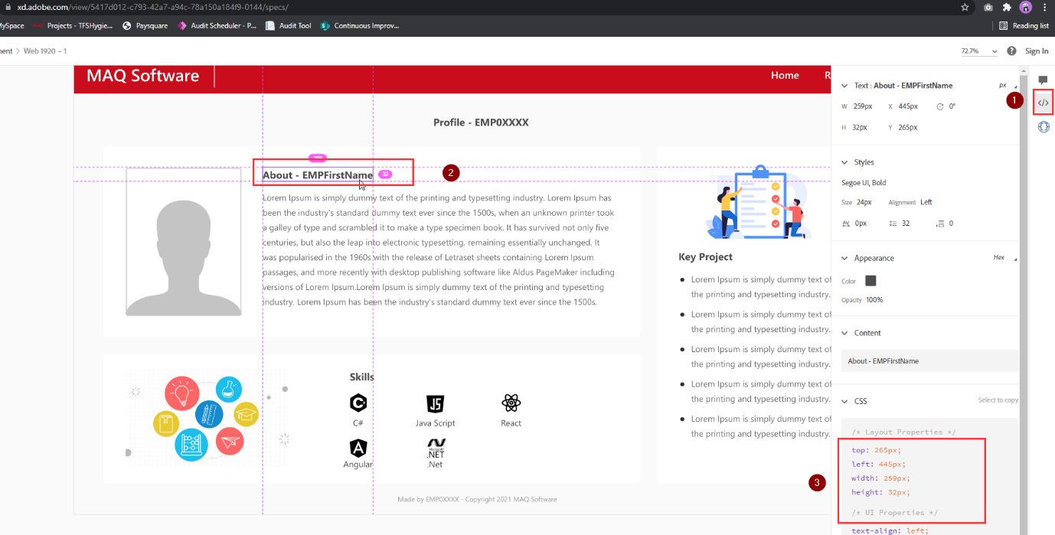
- To download the images, shown in the mock-up,
- click the </> icon,
- click on the image which you need.
- Click on Download.

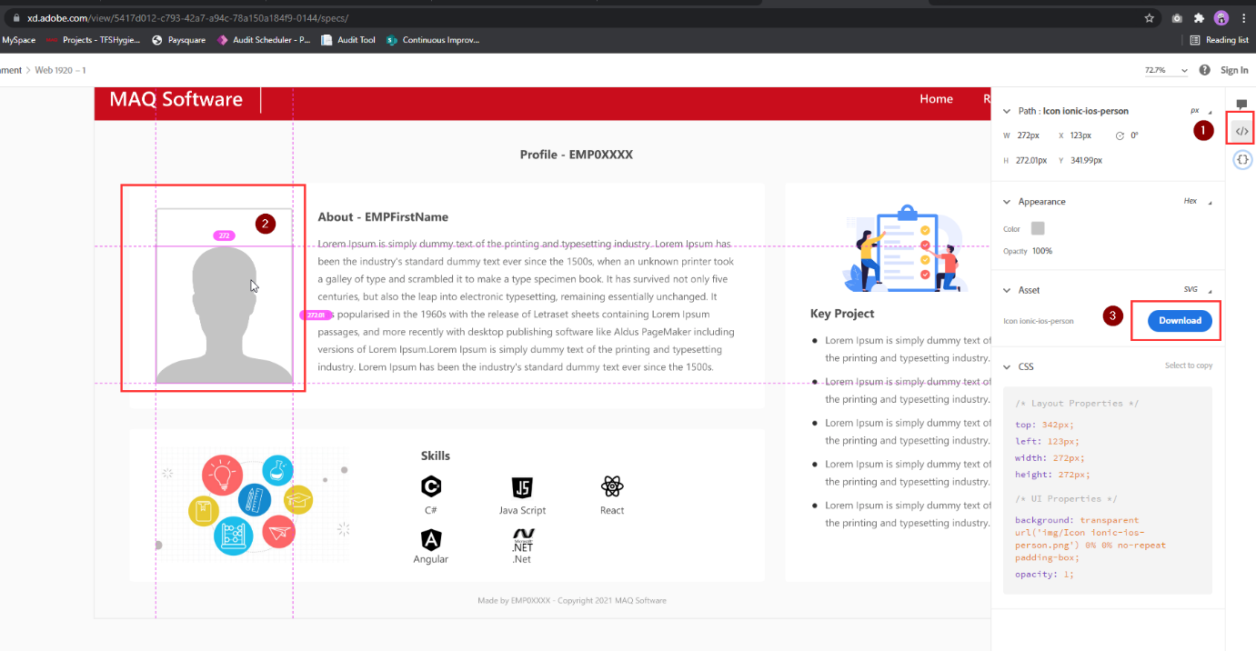

- How to check the tile size and space?
    - Click on </> icon.
    - Just select the component for which you want to know the size.
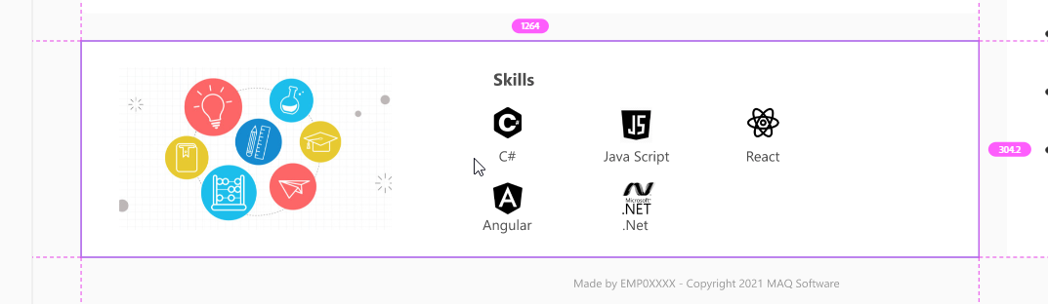
How to know the spacing between 2 components?
    - Click on </> icon.
    - Select the first component.
    - Hover on the next component to know the spacing (Do not click on the second component)
